FOR IMMEDIATE RELEASE

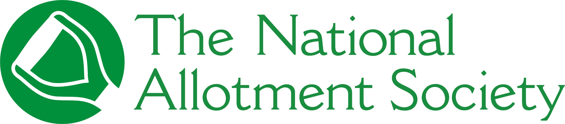

PRESS RELEASE

Thursday 30th July 2026

National award finalist spot highlights commitment to preservation of UK plots

The National Allotment Society (NAS), the UK’s leading representative body for allotment holders, has been shortlisted as a finalist in the Best UK Association (over 1,500 members) category at this year’s Association Excellence Awards.
The Awards celebrate the vital work and outstanding achievements associations, trade bodies, professional organisations and chartered institutes do for and on behalf of their members to ensure their voices are heard and their causes are championed.
With more than 132,000 members, NAS has been recognised for its continued commitment to supporting and championing allotment holders, promoting the benefits of allotment gardening, and providing expert advice, guidance and resources to its growing membership and the wider allotment community.
Over the past year, the Society has continued to strengthen its support for members through expanded educational resources, campaigns to protect and promote allotment sites, enhanced member benefits, and initiatives that encourage more people to experience the physical, mental and environmental benefits of growing their own food.
Commenting on the national award finalist spot, Sonia Gallagher, National Secretary and General Manager at NAS, said: “As the UK’s leading voice for allotments, we are delighted to be recognised as finalists in the Association Excellence Awards.
“For more than a century, NAS has been at the heart of protecting and promoting allotments across the UK. Being shortlisted reflects the dedication of our staff, trustees, volunteers and, most importantly, our members, who work tirelessly to keep the allotment movement thriving.”
Winners for all 20 categories will be officially announced at an awards ceremony to be held on Friday 13th November at the Hilton London Bankside.
To view the full list of finalists at the Association Excellence Awards 2026, visit https://associationexcellenceawards.co.uk/

[ENDS]

Please direct any press enquiries to Emma Speirs on 01536 682800 or email emma.speirs@ballyhoo-pr.co.uk

NOTES TO EDITORS

Photo included of National Allotment Society representatives at their recent AGM.

About the National Allotment Society
With over 132,000 members, The National Allotment Society (NAS) is the leading representative body for UK allotment holders. Its mission is to protect, promote and preserve allotments for future generations.

NAS works with allotment sites, associations, councils and individual plot holders to provide advice and guidance on a range of issues including site management, environmental concerns, tenancy agreements and fundraising.

For more information, go to https://thenas.org.uk/ or follow NAS on Facebook and Instagram

